Exercise 1 Unit :

**To solve the exercises, create a document with screenshots including the settings for each part.**

1. Create an empty virtual machine and configure the following settings:
   * For Windows 10 (64 bits, or 32 if you do not have enough RAM in your physical computer).
   * 2GB of RAM memory.
   * Boot order (CD and hard drive).
   * Two hard drives: one with 50 GB for the operating system and another one with 30 GB empty. Select the type of disk that can dynamically increase.
   * The first thing we have to do is create a new virtual machine in our VirtualBox

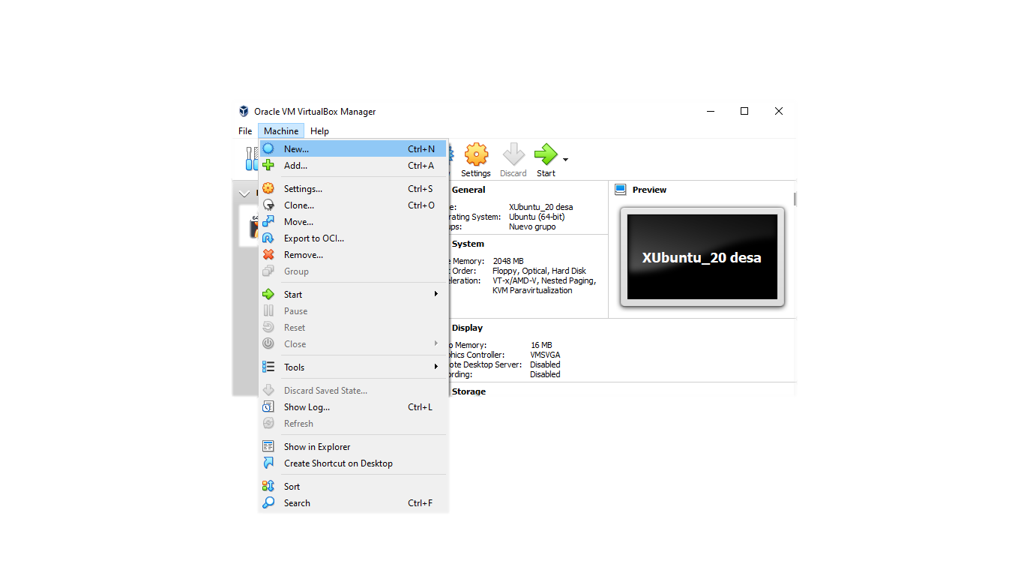

* Then, we chose the operating system we want

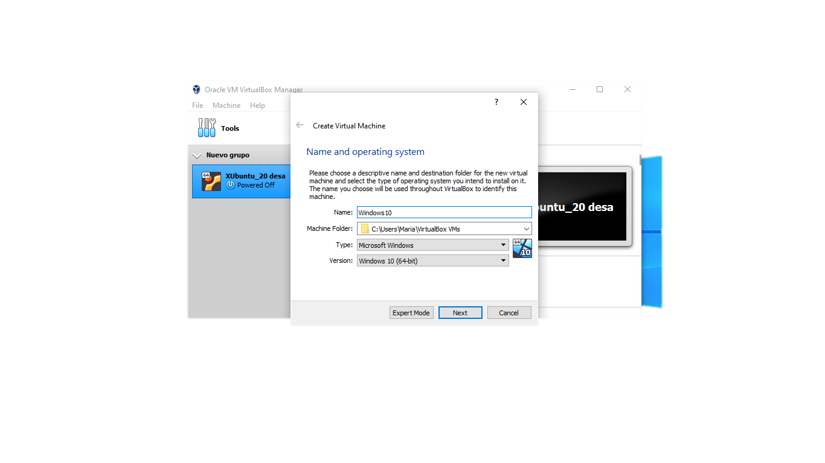

We have to take into account that if we don´t have the necessary space, instead of choosing the 64-bit we would have to choose the 32-bit.

* After this, we have to chose the Memory size, in this case 2GB

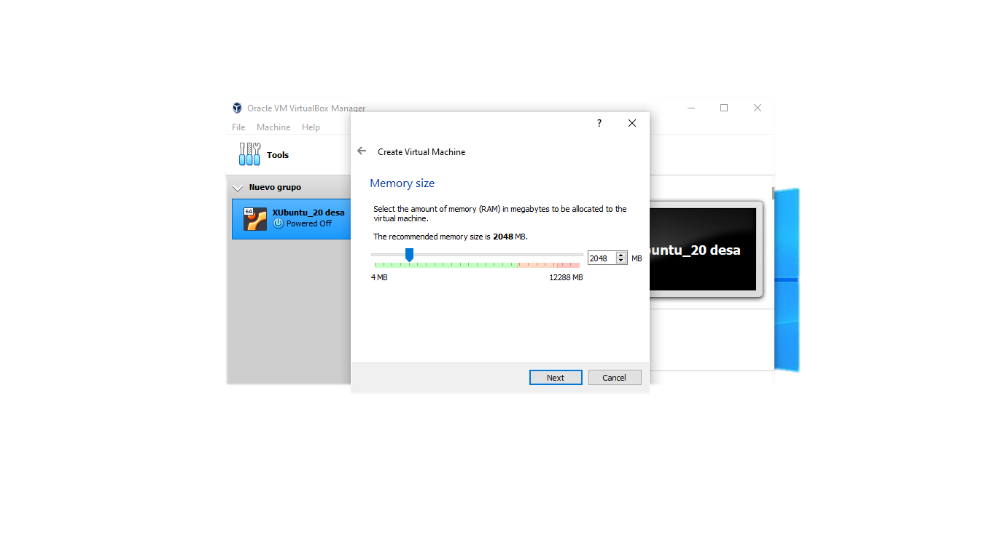

* We create the first disk using the VDI type, and for this exercise it must have 50.00GB

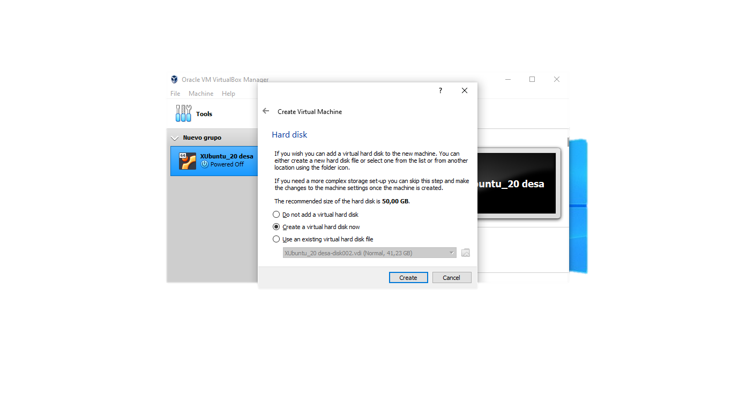

* And we chose the dynamically allocated option

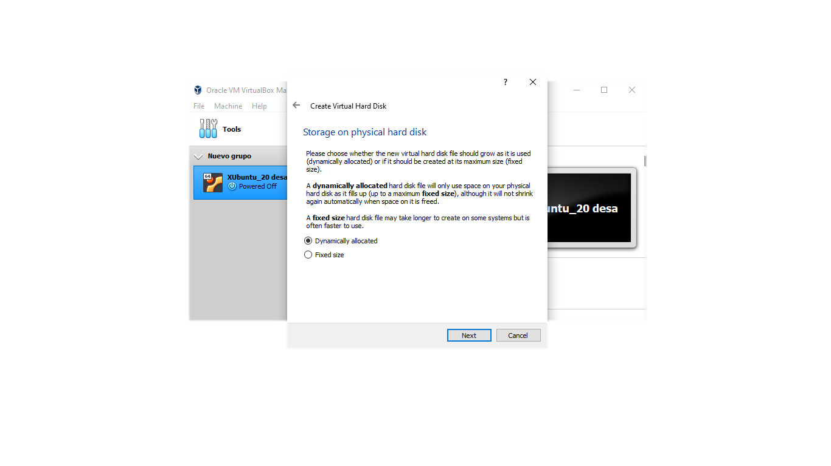

* Clicking on System we can change the Boot order

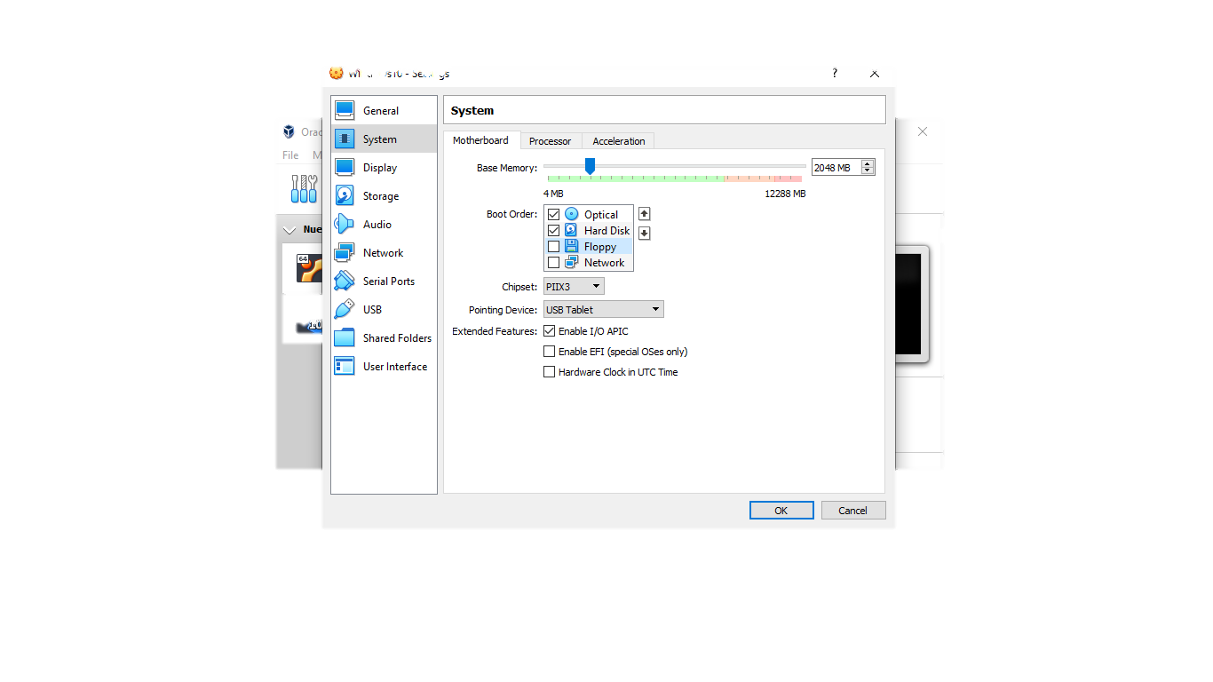

* At last we create the 30.00GB disk.

